4

DBMS - Mini Project NGO Course Management System

Submitted by:

Kshitij G Saha

PES1UG20CS222

Section D

**ER Diagram**

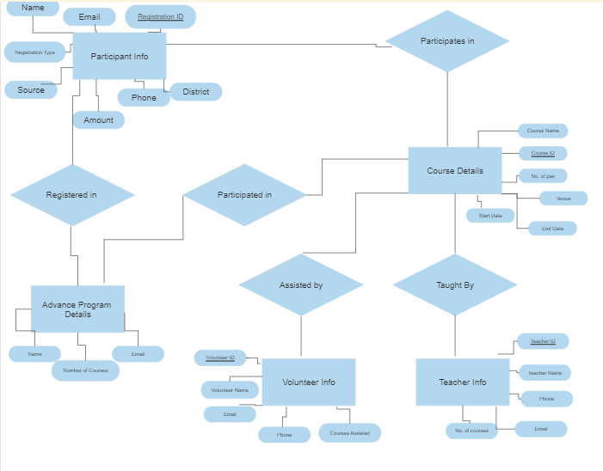

# Relational Schema

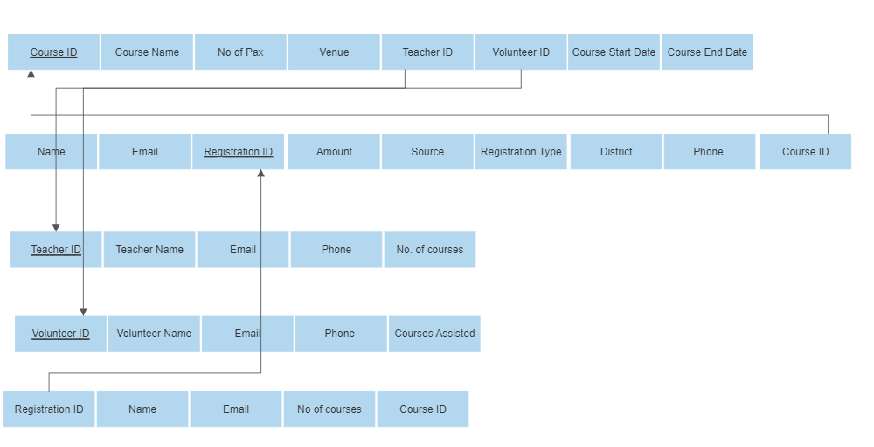

**DDL statements - Building the database**

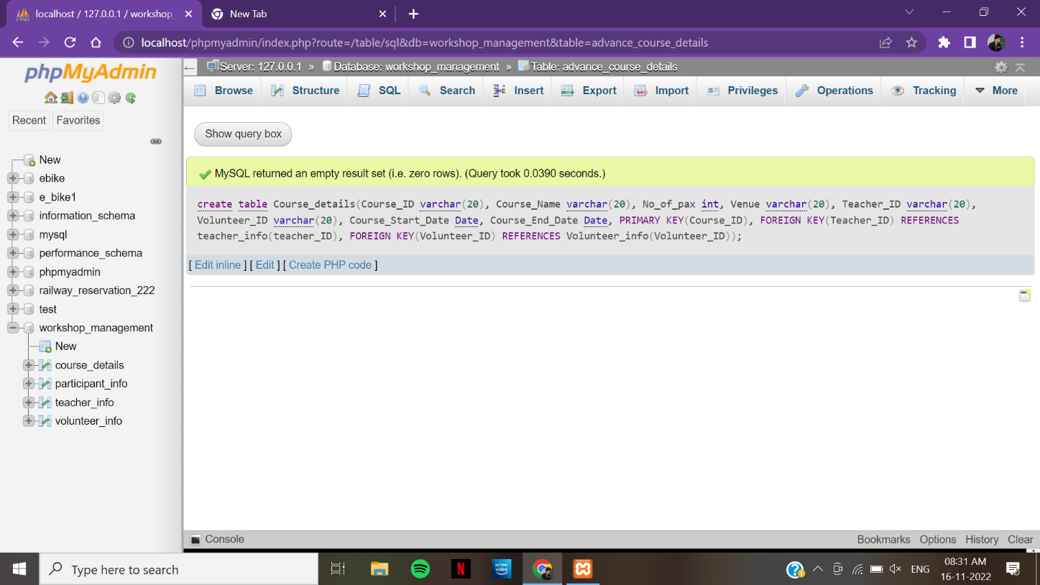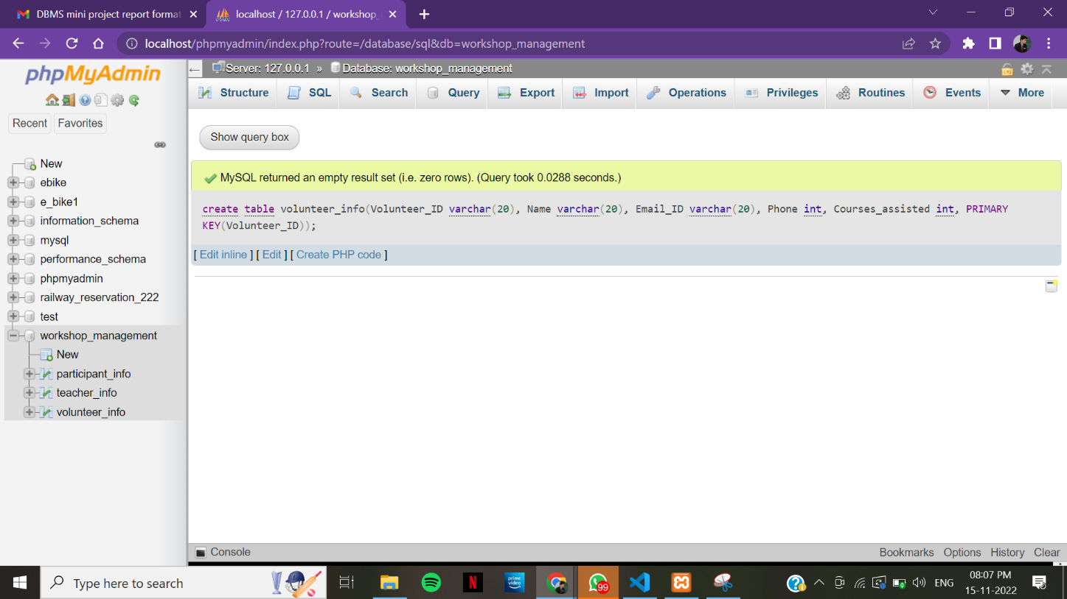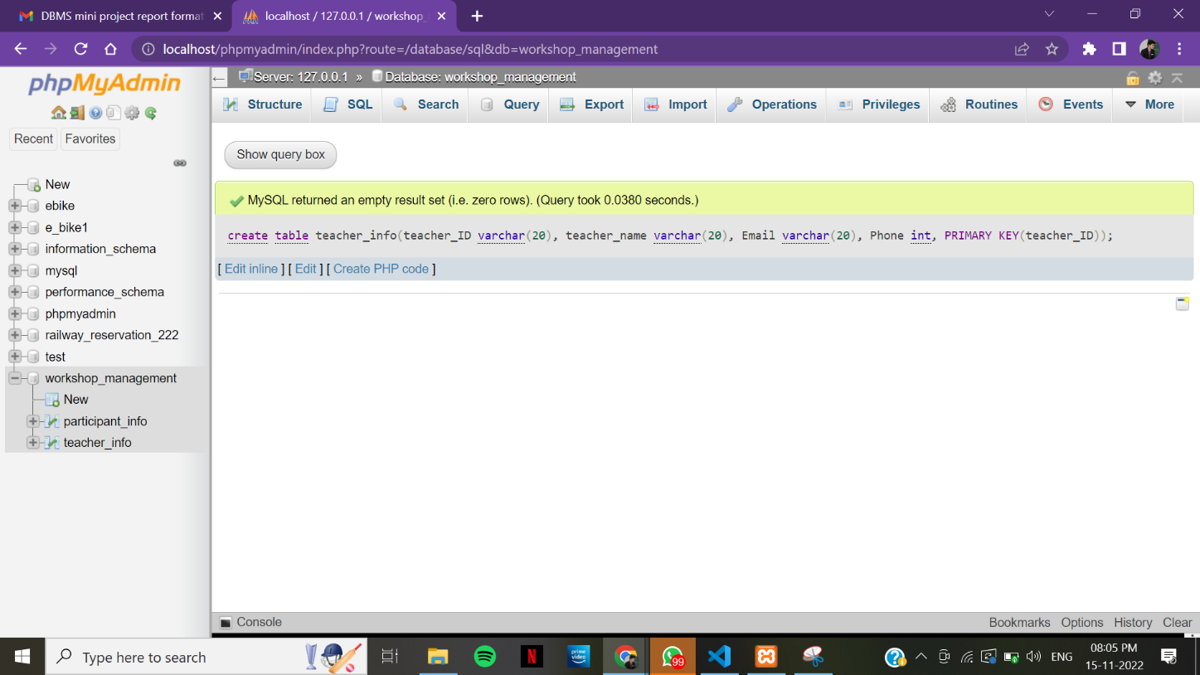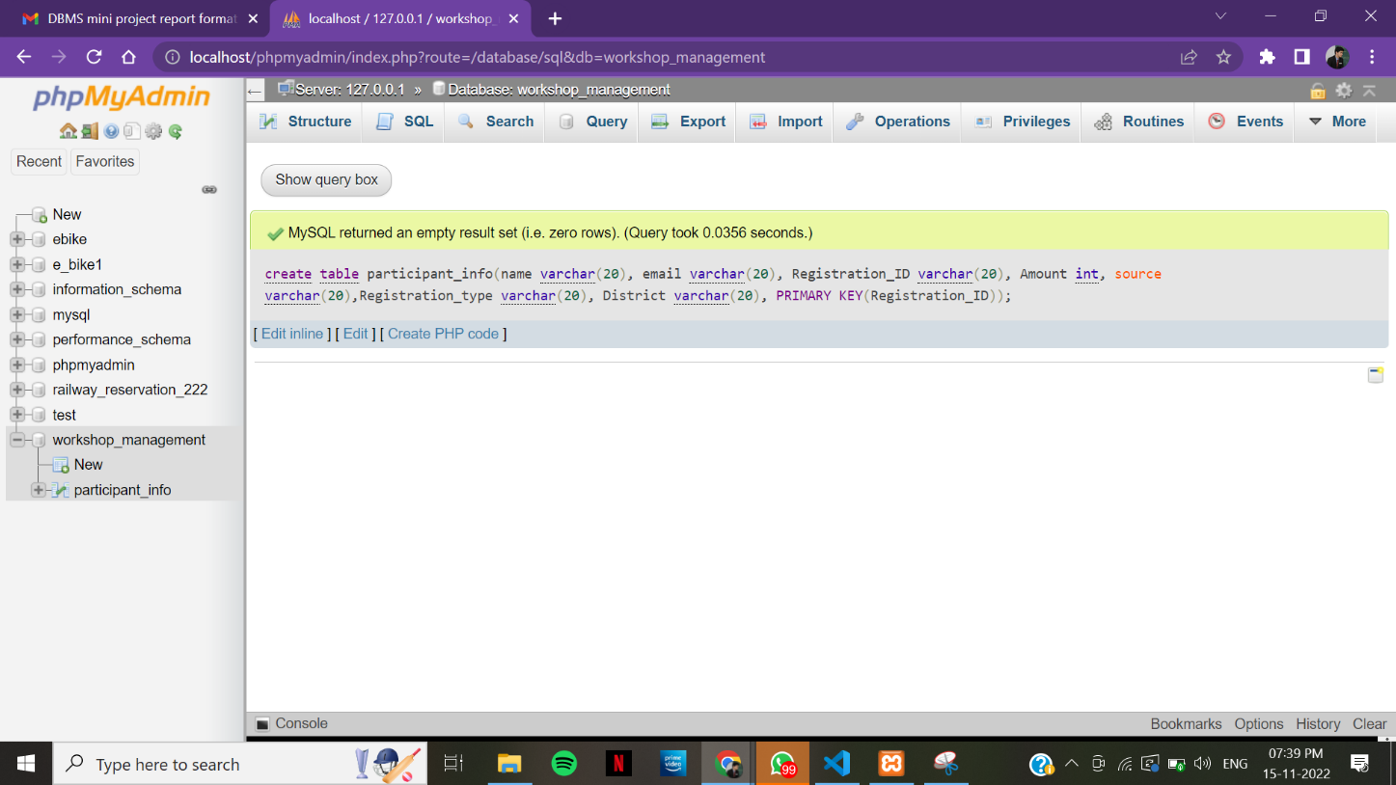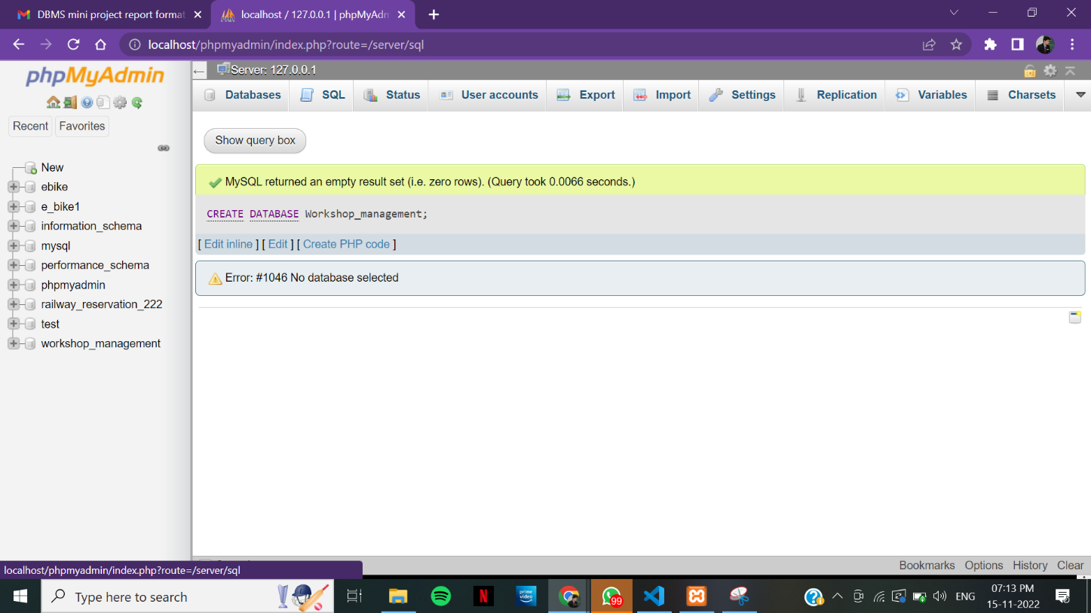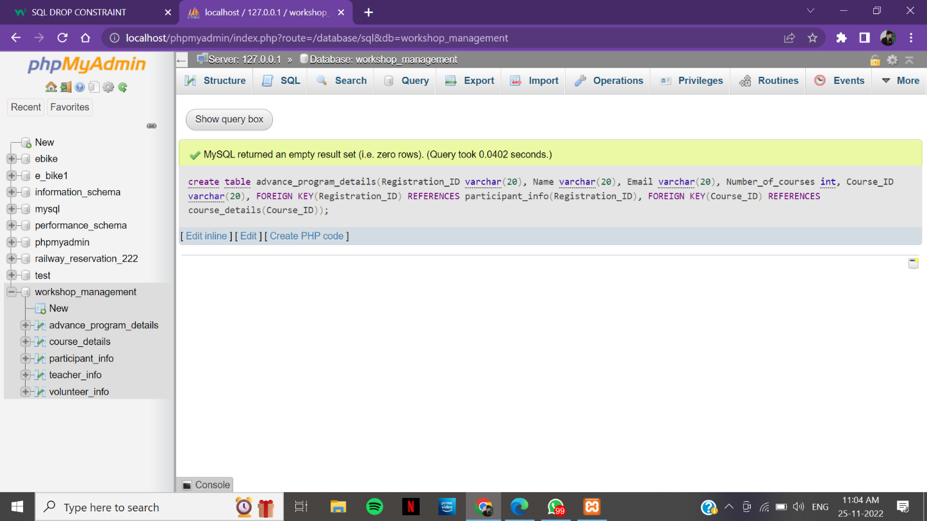

# Populating the Database

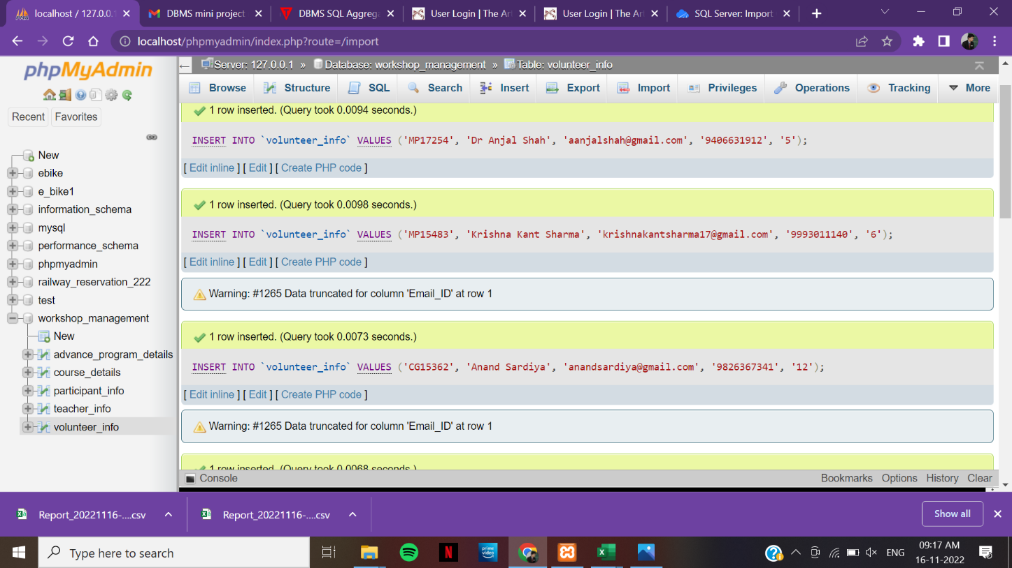

**Join Queries**

Showcase at least 4 join queries

Write the query in English Language, Show the equivalent SQL statement and also a screenshot of the query and the results

/* JOIN course_details and teacher_info with teacher_ID*/

SELECT * FROM course_details INNER JOIN teacher_info ON course_details.teacher_ID = teacher_info.teacher_ID;

/* JOIN course_details and volunteer_info with volunteer_ID*/

SELECT * FROM course_details INNER JOIN volunteer_info ON course_details.Volunteer_ID = volunteer_info.volunteer_ID;

/* JOIN teacher_info and course_details with teacher_ID*/

SELECT * FROM teacher_info INNER JOIN course_details ON teacher_info.teacher_ID = course_details.teacher_ID;

/* Join participant_info and course_details with Course_ID*/

SELECT * FROM participant_info INNER JOIN course_details ON participant_info.Course_ID = course_details.Course_ID;

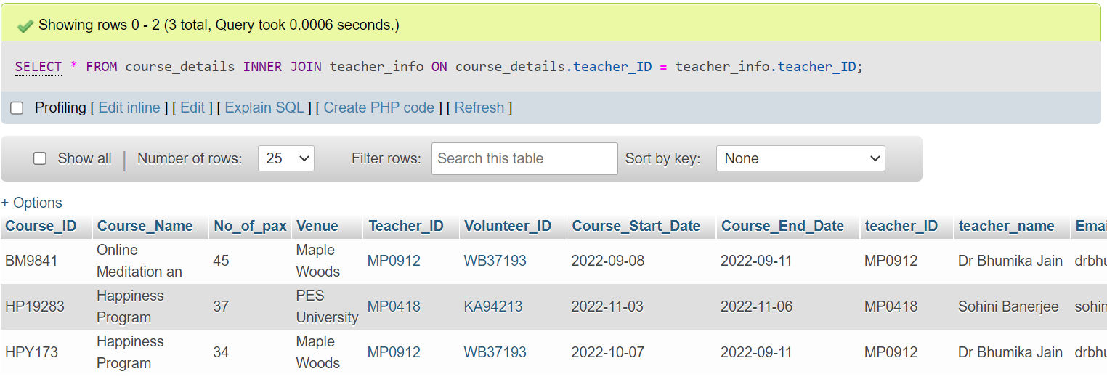

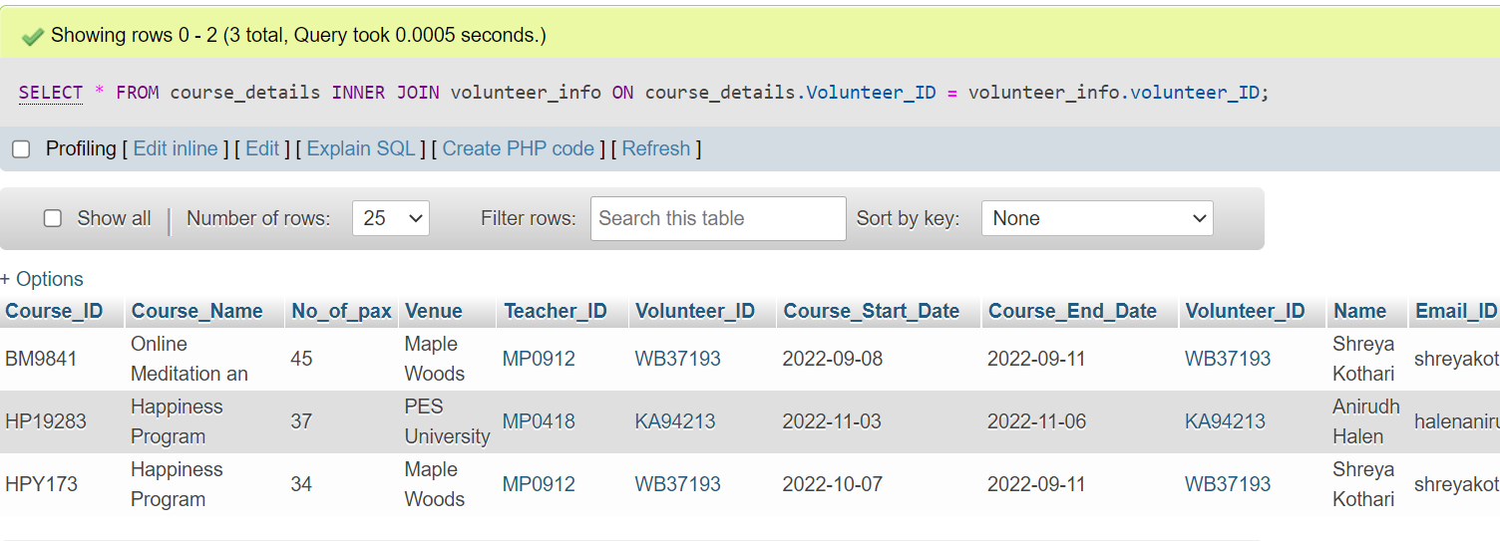

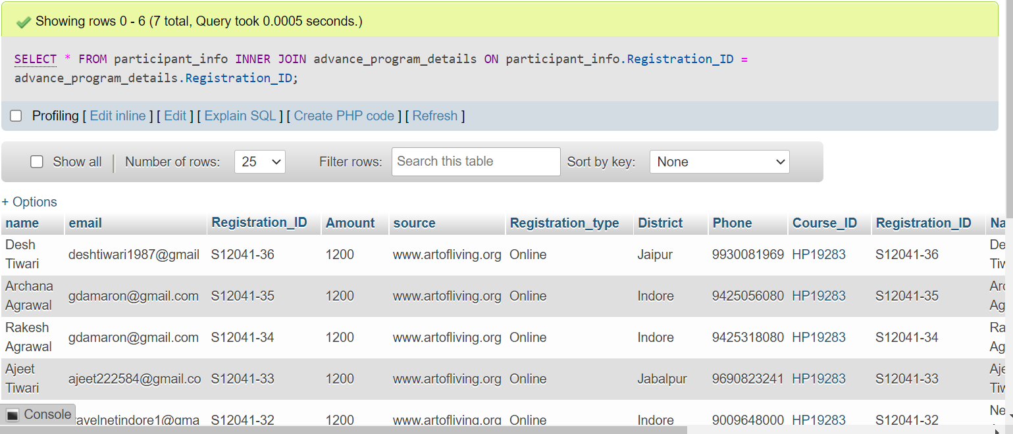

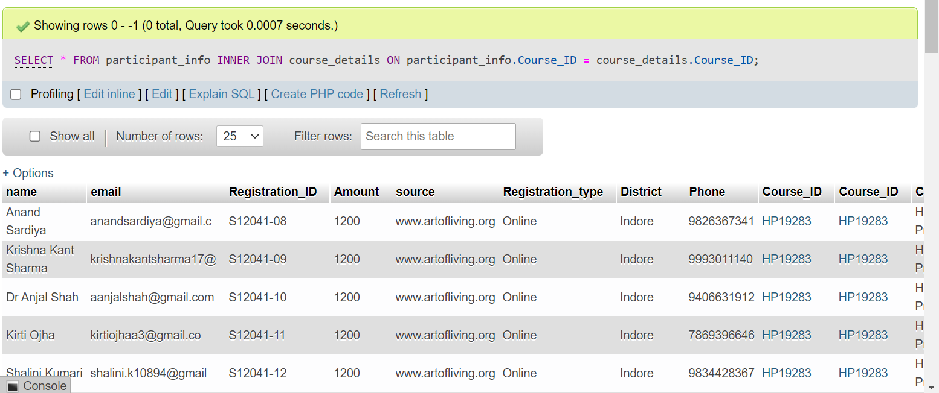

# Aggregate Functions

Showcase at least 4 Aggregate function queries

Write the query in English Language, Show the equivalent SQL statement and also a screenshot of the query and the results

/*Aggregate function to select teacher with max no_of-courses*/

SELECT * FROM teacher_info WHERE no_of_courses = (SELECT MAX(no_of_courses) FROM teacher_info);

/*Aggregate function to select volunteer with max Courses_assisted*/

SELECT * FROM volunteer_info WHERE Courses_assisted = (SELECT MAX(Courses_assisted) FROM volunteer_info);

/*Aggregate function to Show total number of courses in course_details table*/

SELECT COUNT(*) FROM course_details;

/*Aggregate function to show total number of participants in advance_program_details table*/

SELECT COUNT(*) FROM advance_program_details;

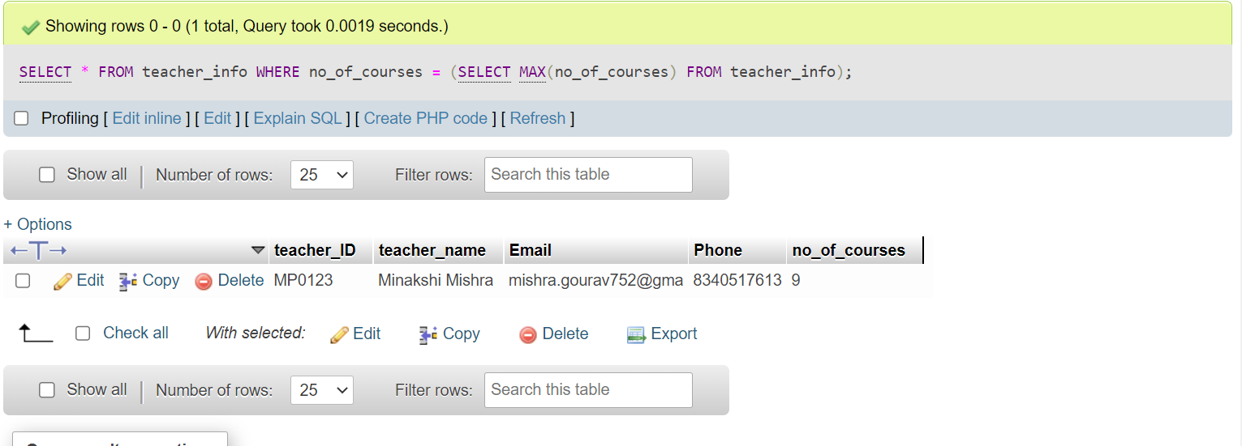

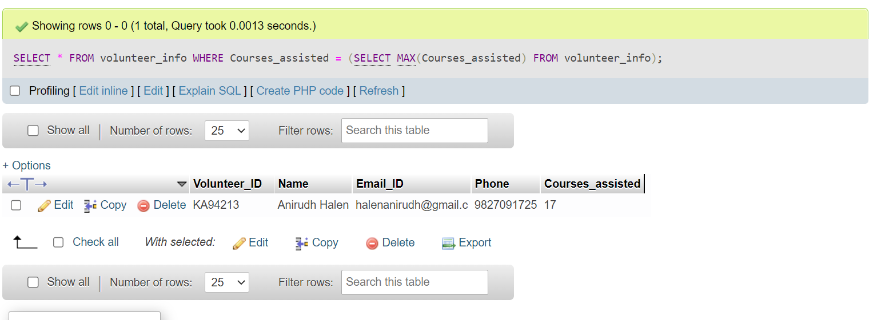

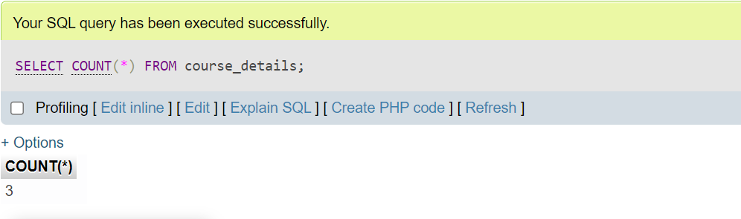

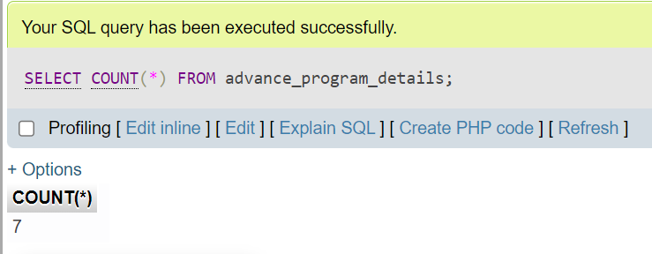

# Set Operations

Showcase at least 4 Set Operations queries

Write the query in English Language, Show the equivalent SQL statement and also a screenshot of the query and the results

/* Set operation to get list of course_details with Course_Start_Date as 2022-09-08 and Course_End_Date as 2022-09-11 and No_of_pax is above 40*/

SELECT * FROM course_details WHERE Course_Start_Date = '2022-09-08' AND Course_End_Date = '2022-09-11' AND No_of_pax > 40;

/*Set operation to get list of participants where Amount is 1200 and Registration_type is 'Online'*/

SELECT * FROM participant_info WHERE Amount = 1200 AND Registration_type = 'Online';

/*Set operation to get list of participants whose District is Indore or Bhopal or Damoh*/

SELECT * FROM participant_info WHERE District = 'Indore' OR District = 'Bhopal' OR District = 'Damoh';

/* Set operation to get list of participants whose Course_ID is HP173 and Registration_type is 'Online'*/

SELECT * FROM participant_info WHERE Course_ID = 'HP173' AND Registration_type = 'Online';

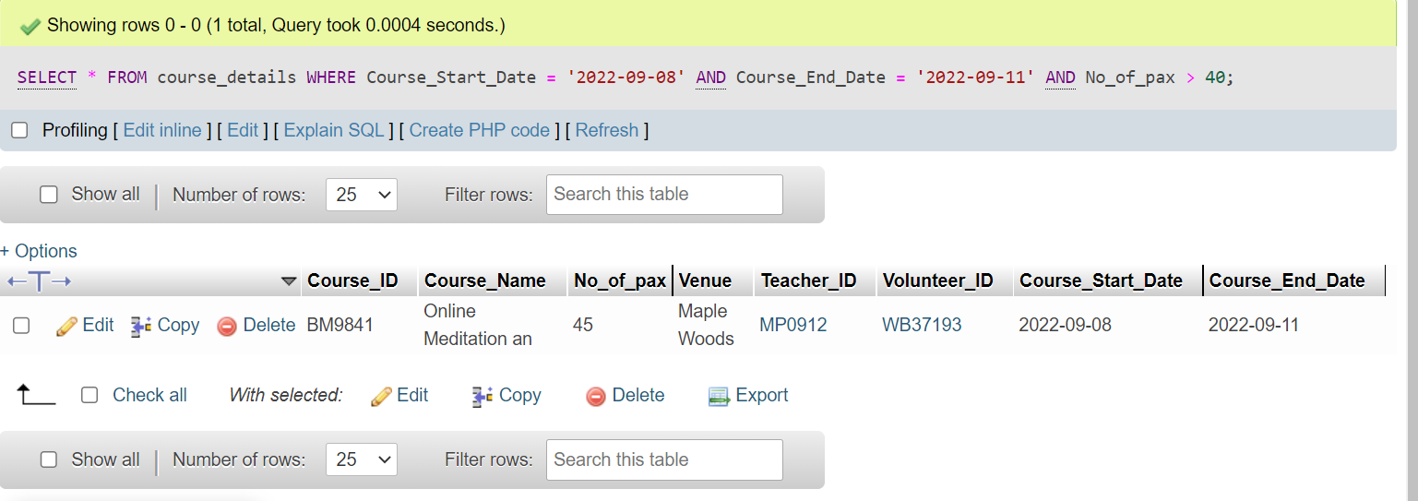

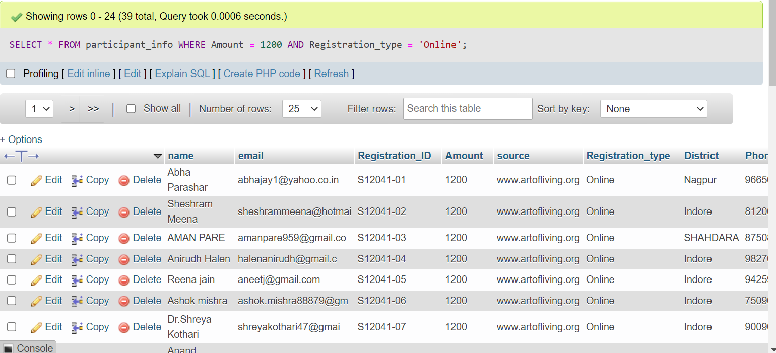

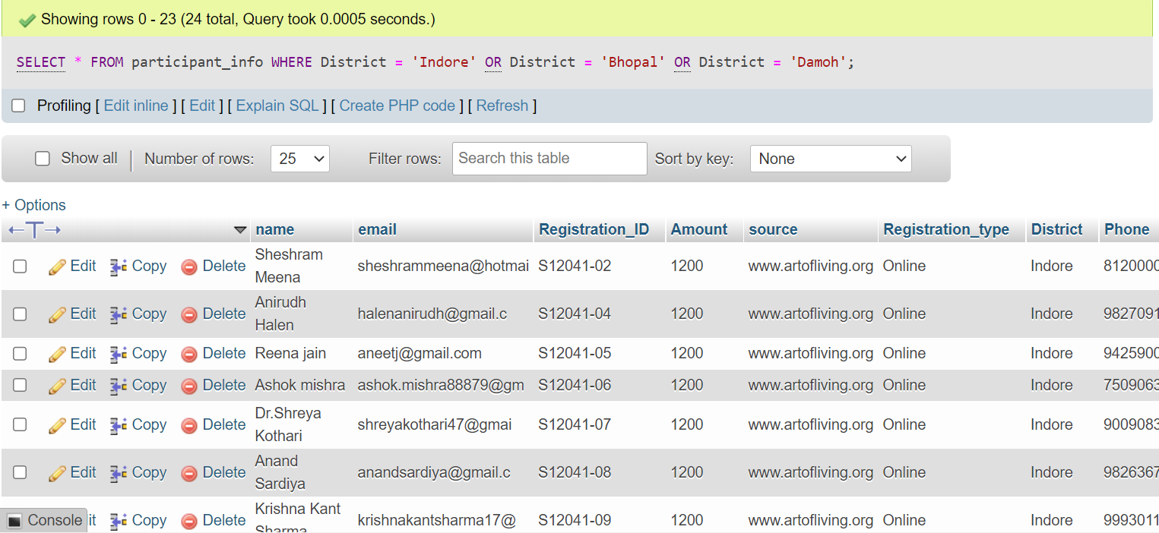

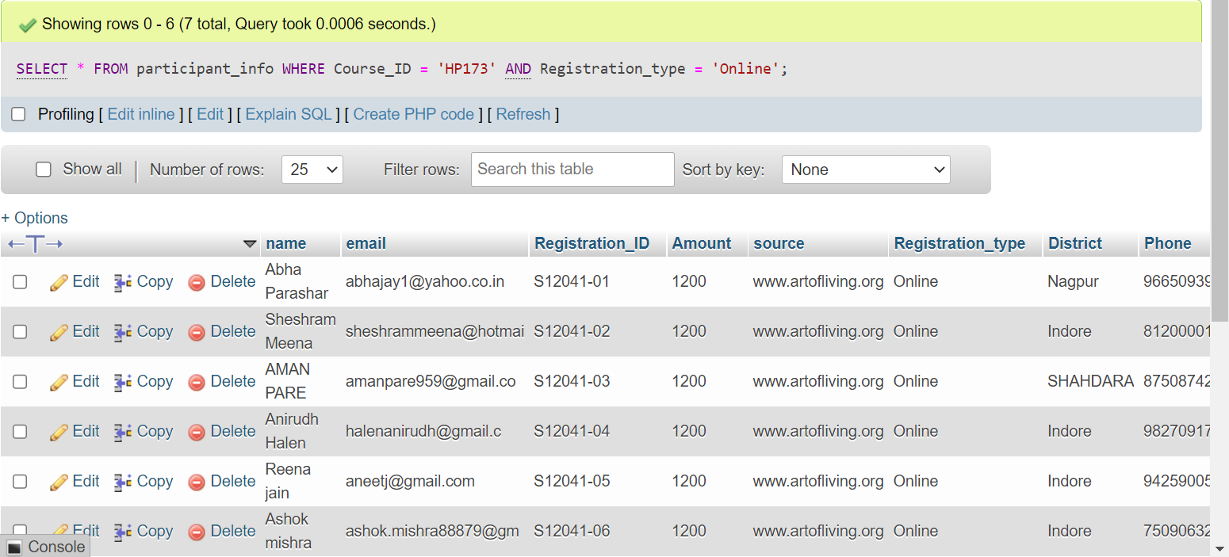

# Functions and Procedures

Create a Function and Procedure. State the objective of the function / Procedure. Run and display the results.

--Functions

/* Create function to check if Number_of_courses>4 in advance_program_details*/

DELIMITER &&

CREATE FUNCTION check_courses

(

    @Number_of_courses INT

)

RETURNS BIT

AS

BEGIN

    DECLARE @result BIT

    IF @Number_of_courses > 4

        SET @result = 1

    ELSE

        SET @result = 0

    RETURN @result

END &&

DELIMITER ;

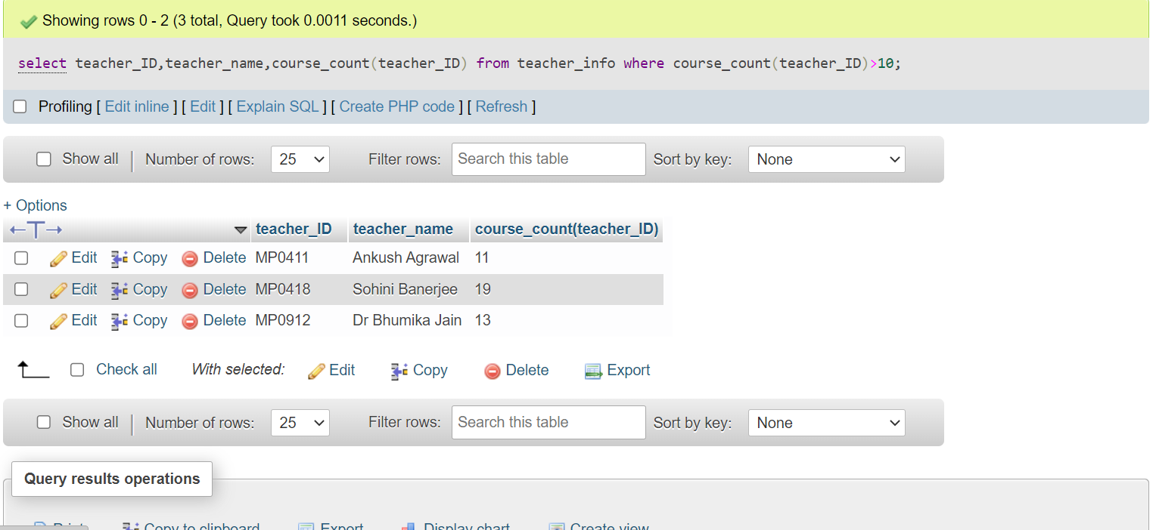

--Procedure--

/* Create procedure to display rows where Number_of_courses>4 in advance_program_details*/

DELIMITER &&

CREATE PROCEDURE display_advance_program_details

BEGIN

SELECT * FROM advance_program_details WHERE Number_of_courses>4;

END &&;

DELIMITER;

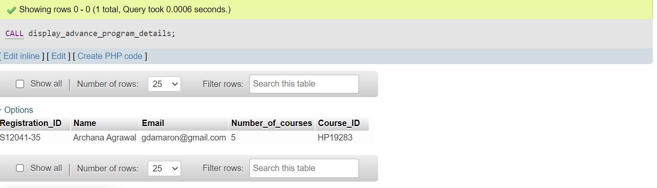

# Triggers and Cursors

Create a Trigger and a Cursor. State the objective. Run and display the results.

/* Create trigger to increment no_of_courses by 1 in teacher_info table if teacher_ID in teacher_info table is same as teacher_ID in course_details table*/

CREATE TRIGGER increment_no_of_courses

AFTER INSERT ON course_details

FOR EACH ROW

BEGIN

UPDATE teacher_info SET no_of_courses = no_of_courses + 1 WHERE teacher_ID = NEW.teacher_ID;

END;

/*cursor to obtain the info of first and last row from participant_info table*/

DECLARE cursor1 CURSOR FOR SELECT * FROM participant_info WHERE Course_ID = HPY FROM participant_info);

# Developing a Frontend

The frontend should support

1. Addition, Modification and Deletion of records from any chosen table
2. There should be a window to accept and run any SQL statement and display the result

